

Mentoring, Training & Placements Department
Daily Report 02-04-2026
Description |  | Total to be received | Received till Date | Received Date | To be received

II | Staff Attendance
S.No | Dept. | Category | On Rolls | Absent | DQI | DQI Performance | Overall DQI | Overall Performance
1 | MTP |  | 8 | 1

 | III. Students’ Attendance:
IV | MTP:  SAMUEL  - Advance Auto Parts - has confirmed the hiring process for 2026 batch. Job notification has been published on POD. 400+ students are given eligibility. Registration is in progress  - JPMC - All the 3rd years who have received Coding test link have finished their test (approx 380). Video Interview is scheduled which should be finished by 4th April. Coordinating with students.  KABITA  POONAM  - The Volvo Eicher Commercial Vehicles (VECV) hiring updates, 11 students from AME/Mech are shortlisted for the off-campus drive scheduled on April 9th and 10th, 2026 at CVR Engineering College.  - Reliable Techno System: 15 Students will be attending the hiring process on 04th April 2026 at Reliable Techno System office address: - 4th floor, Vijaya Towers at 11AM sharp. Rounds: Written Test (Pen & Paper-based test), Technical, HR and it will be full day process.  - An orientation and training session was conducted by Dr. K V M Achuta Ramaiah on 2nd April’26, 11 AM to 1.30 PM at P-417, in view of Calfus- Oracle fusion Technical Intern, Communication Round (2027 batch). 9 students attended this session.  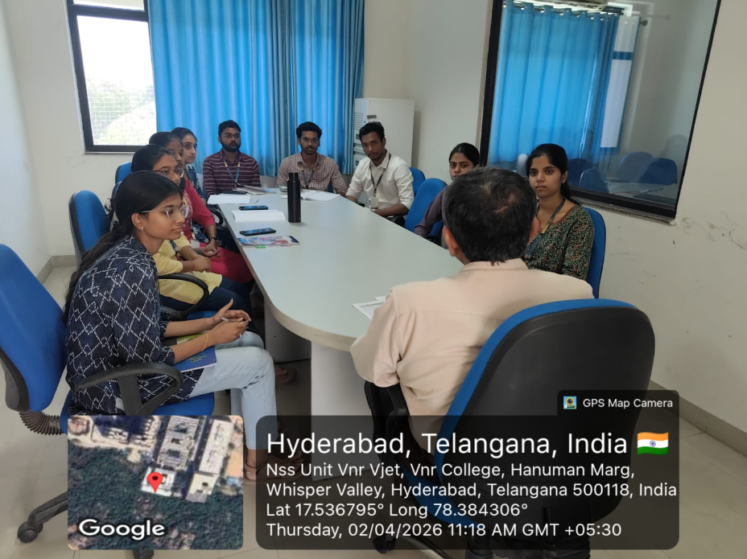 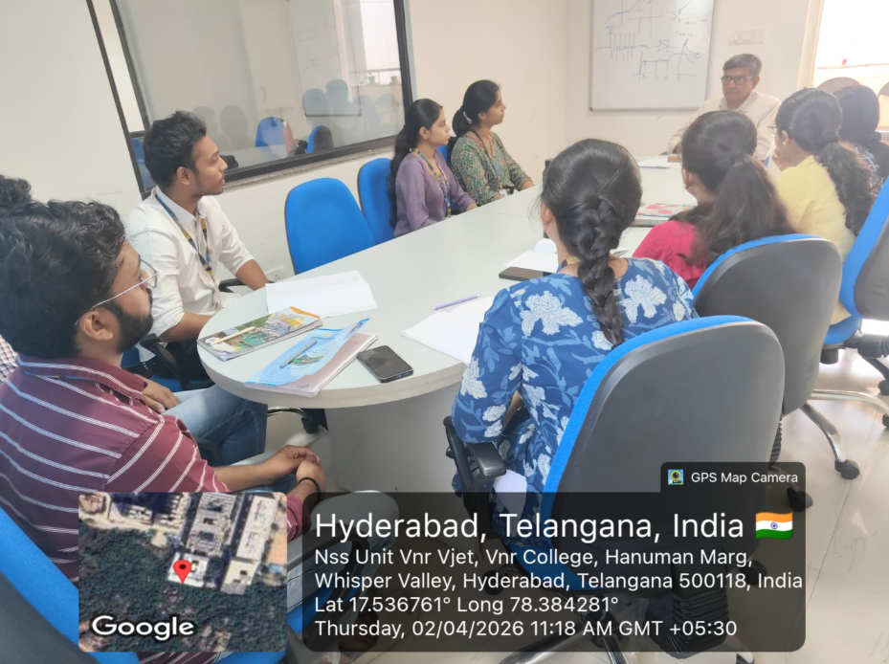  V HOD-CSE (CSDS&AIDS):  VI HOD-IT:  VII HOD-ECE:  2025 2026 Batch Plis open Summary:  CSE CSBS AIML IOT DS CyS AIDS IT ECE EEE EIE ME CE AE M.TECH TOTAL  359 65 276 85 187 63 65 249 207 83 92 57 62 19 18 1887  2025
VIII Classwork Adjustment / Lectures Interchanged:
S. No. | Dept | Subject | Adjusted from | Adjusted to

IX. Participation by Staff/Students:
S.No | Name | Event | Status (delegate /paper)resent, speaker) | Date and  Duration

X | Particulars of Library Services or Transactions: | No.s

For Head of the Department.

